
Part A
51． Directions:
Suppose you are a librarian in your university． Write a notice of about 100 words． providing the newly-enrolled international students with relevant information about the library．
You should write neatly on the ANSWER SHEET．
Do not sign your own name at the end of the notice． Use Li Ming instead．
Do not write the address． (10 points)
Notice
September 11th
Welcome to our university. I’m the librarian at the university. This notice is for the purpose of informing you of the relevant information about the library. The following notes about the library you need to pay attention to.
The library is on the south of the campus, right next to the gym. It’s open from 7:00 a.m. to 9 p.m. except on Friday, on which the library closes at 5 p.m. Besides, after registered with your personal information, you can use the student card as the access card. Moreover, on the basement floor is the hot water supply which is charged by quantity of water. There are 3 hot water machines opening 24/7.
I hope you find the above information useful and I would be ready to discuss the matter with you to further details. If you have any questions, you are free to contact at 192389 in the working hours.
Library of Tsing Hua University

Part B
52． Directions:
Write an essay of 160-200 words based on the following pictures． In your essay， you should
1) describe the pictures briefly
2) interpret the meaning ， and
3) give your comments
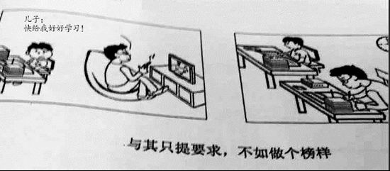

In the pictures above are two parents, who behave differently towards their children’s education. The one on the left requires his son to study merely towards oral requirement, while his counterpart chooses to model the educational behavior himself. The difference between these two behaviors might lead to thoroughly opposite results,which could go stray from the original expectation. As far as I am concerned, when fostering children, modeling education is far more useful than verbal words. The following points can account for my opinion.
In the first place, during modeling the educational behavior, the communication between generations can be enhanced. Based on a most recent study, a growing body of evidence showed that most successful social elites, who have decent manners, have admitted that their parents communicate a lot when modeling their behavior. Meanwhile, emotional factors do play an important role in cultivating children's behavior. When modeling the behavior, the positive emotion, which is helpful for education, can be triggered. A classic case in point is one of my classmates, whose parents set an example of reading, in which they fostered a harmonious relationship. Thus, from this standing point, there is nothing more beneficial and challenging than teaching by example.
In view of the arguments above, we can safely draw a conclusion that with the ever-increasing material and cultural life, if we try our utmost to instruct the future generation by setting example, our tomorrow will be both promising and rosy.

51. Directions:
You are going to host a club reading session. Write an email of about 100 words recommending a book to the club members.
You should state reasons for your recommendation.
You should write neatly on the ANSWER SHEET.
Do not sign your own name at the end of the letter. Use Li Ming instead.
Do not write the address. (10 points)
Dear club members,
I’m the manager of the reading club, Liming. I’m writing this email to inform you of the reading session next week. During the session, a book will be read together. I’m recommending this book for several reasons.
This book, A tale of two cities, is a long novel, which is a masterpiece, written by the famous British writer, Charles Dickens. It’s a story, which revealed the contrast between the cities under the industrial revolution. After finishing reading the book, you will have a basic grasp of the development of British capitalism. Besides, since it’s an English book, we can appreciate the beauty of English literature.
The book is really worth praising and attention. Hopefully, you will like it.

Yours sincerely,
Liming

Part B
52. Directions:
Write an essay of 160-200 words based on the following drawing. In your essay you should
1) describe the drawing briefly
2) explain its intended meaning, and
3) give your comments
You should write neatly on the ANSWER SHEET. (20 points)
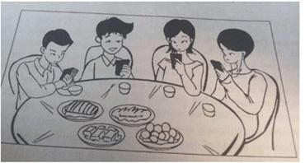

In the picture given above are a group of people,who are eating around the same table. However, their attention are not on the people around, but on the cyberworld of cellphone. What the picture conveys goes far beyond merely the phenomenon of cellphone using. Instead, it reflected the distances between families and friends are widened by the appearance of technology. As far as I am concerned, putting off the cellphone timely is of great necessity. The following points can account for my opinion.
In the first place, due to the busy schedule of university life, college students, who are engaged in studying, must find it helpful for them to improve efficiency when putting off the cellphone. Based on a most recent study, a growing body of evidence showed that most successful social elites, who are not addicted to the cellphone, have admitted that not using cellphone releases their attention and enables them to finish the task better. Meanwhile, when we put off the phone, the communication between individuals can be enhanced. A classic case in point is one of my classmates, who never use cellphone when having dinner with others. He fostered a wide networks among classmates. Thus, from this standing point, there is nothing more beneficial and challenging than putting of the phone timely.
In view of the arguments above, we can safely draw a conclusion that with the ever-increasing material and cultural life, if we try our utmost to balance the usage of life and phone, our tomorrow will be both promising and rosy.

You are to write an email to James Cook, a newly-arrived Australian professor, recommending some tourist attractions in your city. Please give reasons for your recommendation.
You should write neatly on the ANSWER SHEET.
Do not sign your own name at the end of the email. Use “Li Ming” instead.
Do not write the address. (10 points)

Dear James Cook,
I’m Liming.I’m really delighted to know about your trip to my city next week. I'm writing this letter to share some of my recommendations for tourist attractions, which you might be interested in visiting.
The first place you should never miss is the Summer Palace, which is famous for its ancient garden and history. If you visit there, you will be astonished at its grand views and landscapes. After visiting the Summer Palace, spare 2 hours for the National Museum, in which we can appreciate the national treasure and cultural relics. As I know, you are a culture mania, therefore, this place suits your best. At dinner time, across the museum, there is a walking street, in which peddlers sell street food all day long. It’s the best place to sample some local snacks.
Again, I'm very pleased to know your plan. I hope my advice will be helpful for the trip.
Sincerely yours,
Li Ming.

52. Directions：
Write an essay of 160-200 words based on the following pictures. In your essay, you should
1)describe the pictures briefly,
2)interpret the meaning , and
3)give your comments.
You should write neatly on the ANSWER SHEET. (20 points )
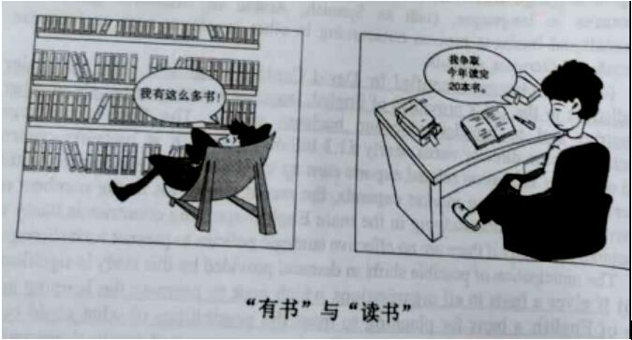

In the pictures given above are two students,who treat books in a different way. The one on the left possessed a shelf of books without reading any of them, while his counterpart chose not to buy an enormous number of books, but to digest 20 books within a year. The difference between these two behaviors might lead to thoroughly opposite results,which could go stray from the original expectation.As far as I am concerned, when learning knowledge, reading quality is far more useful than reading quantity. The following points can account for my opinion.
In the first place, due to the busy schedule of university life, college students, who are engaged in studying, must find it helpful for them to improve efficiency when focusing on reading quality .Based on a most recent study, a growing body of evidence showed that most successful college students who have a busy campus life, have admitted that they only absorb a few books each year. Meanwhile, our interests can be satisfied when we put emphasis on reading quality. A classic case in point is one of my classmates, who reads 20 books of literature each year and later became an expert in this area.Thus, from this standing point, there is nothing more beneficial and challenging than reading reading intensively.
In view of the arguments above, we can safely draw a conclusion that with the ever-increasing educational and cultural life, if we try our utmost to balance the quality and quantity of study, our tomorrow will be both promising and rosy.

51. Directions：
Write an email to all international experts on campus inviting them to attend the graduation ceremony. In your email you should include time, place and other relevant information about the ceremony.
You should write about 100 words neatly on the ANSEWER SHEET
Do not use your own name at the end of the email. Use “Li Ming” instead. (10 points)

Dear Sir or Madam,
I’m Liming, a student in the foreign language department. Recently,the students in our department will graduate. Therefore, I’m writing this letter in order to invite you to attend the forthcoming graduation ceremony.
The ceremony will be hosted in the auditorium on our campus, at 10 o'clock in the morning on next Monday, January 15. It is advisable for you to dress formally. Please let us know your decision as soon as possible so that we could send you further details concerned. Since you are so popular among us that we sincerely hope you could accept this invitation and give the graduates a wonderful memory of our campus.
Thank you for your time and consideration. Hopefully, you could give us an earliest favorable reply.
Yours,
Li Ming

Part B
52. Directions：
Write an essay of 160-200 words based on the picture below. In your essay, you should
1)describe the pictures briefly
2)interpret the meaning and
3)give your comments(20 points)
You should write neatly on the ANSWER SHEET. (20 points )
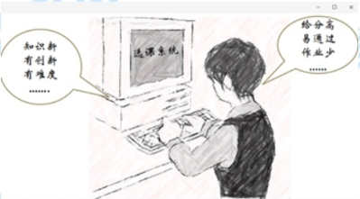

In the picture given above is a classic example of college students,who behave differently when selecting subjects. Those on the left put emphasis on subjects with new knowledge and difficulty, while their counterparts chose the easy ones with high scores and less assignments. The difference between these two behaviors might lead to thoroughly opposite results,which could go stray from the original expectation.As far as I am concerned, when selecting a subject, the difficult and innovative one is far more useful than the easier one. The following points can account for my opinion.
In the first place, during the difficult class, the communication between classmates can be enhanced. Based on a most recent study, a growing body of evidence showed that most successful social elites, who chose difficult classes on campus, have admitted that communication in the class is beneficial. Meanwhile, emotional factors do play an important role in class. When learning innovative knowledge, the positive emotion ,which is helpful for education, can be triggered.A classic case in point is one of my classmates, who is happy with his choice. As a consequence, he gets A in all subjects all the time. Thus, from this standing point, there is nothing more beneficial and challenging than a correct subject.
In view of the arguments above, we can safely draw a conclusion that with the ever-increasing education and cultural life,if we try our utmost to absorb new knowledge, our tomorrow will be both promising and rosy.

Directions：
Suppose you are working for the “Aiding rural Primary School” project of your university write an email to answer the inquiry from an international student volunteer, specifying the details of the project.
You should write about 100 words neatly on the ANSEWER SHEET
Do not use your own name in the email. Use “Li Ming” instead. (10 points)

Dear Jim,

I am quite pleased to receive your inquiry about the “Aiding Rural Primary Schools” project of our university, and I am writing to specify relevant details of the project.
To begin with, the duration of the teaching project is almost 2 months, from January 1st to February 26th. The target candidates should be freshmen or sophomores with a teacher’s certificate. During the project, you will be required to give 3 lessons each day. Therefore, you need to prepare the lesson carefully beforehand. When the project is finished, you will be offered proof of internship, which could be an honor of your future resume.
I hope you find the above information useful and I would be ready to discuss the matter with you for further details. If you have any questions, you are free to contact at 192389 in the working hours.

Yours sincerely,
Li Ming

Part B
Directions：
Write an essay of 160-200 words based on the picture below. In your essay, you should
- describe the pictures briefly
- interpret the meaning and
- give your comments
You should write neatly on the ANSWER SHEET. (20 points )
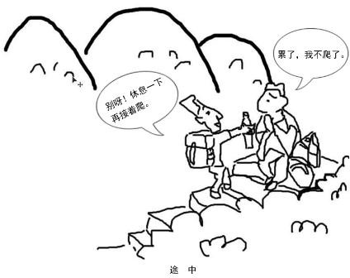

In the picture given above are two hikers,who hold different opinions during a tiring hiking. The one on the left acted positively in the middle of the hiking journey, while his counterpart chose to give up when getting exhausted. The difference between these two attitudes might lead to thoroughly opposite results, which could go stray from the original expectation. As far as I am concerned, when confronting obstacles, facing them directly is far more useful than eluding reality. The following points can account for my opinion.
In the first place, due to the busy schedule of university life, college students, who are engaged in studying, must find it helpful for them to improve efficiency when fixing the problem directly. A classic case in point is one of my classmates, who failed a lot of times in exams. He didn’t give up studying but opted for make-examination. Meanwhile, daring to face setbacks provides a safer environment for both your life and your career. Based on a most recent study, a growing body of evidence showed that most successful social elites, who grow up from ordinary people, have admitted that they will not elude from the harsh reality when facing difficulty. Thus, from this standing point, there is nothing more beneficial and challenging than facing the difficulty directly.
In view of the arguments above, we can safely draw a conclusion that with the ever-increasing material and cultural life, if we try our utmost to overcome the difficulties, our tomorrow will be both promising and rosy.

Part A
51.Directions:
The Student Union of your university has assigned you to inform the international students an upcoming singing contest. Write a notice in about100 words.
Write your answer on the ANSWER SHEET.
Do not use your name in the notice.

Notice
This notice is for the purpose of holding a singing contest. (描述通知)This contest is aimed at enhancing communication between domestic and international students. （通知目的）The following details can account for this event.（过渡句）
First and foremost, the contest will begin at 7:00, Sunday, December 8th, 2019. All the students in our department must participate(be there) on time. It is related to your GPAs. Furthermore, there will be some interactions between performers and audiences. For example, the votes, question&answers. Last but not least, this contest will be held in classroom 202. Please bring your tickets and your student IDs to be checked at the front door.
If you have any questions, you are free to contact at 192389 in the working hours.
Student Union

Write an essay of 160-200 words based on the picture below. In your essay, you should:
1) Describe the picture briefly;
2) Interpret the implied meaning, and
3) Give your comments
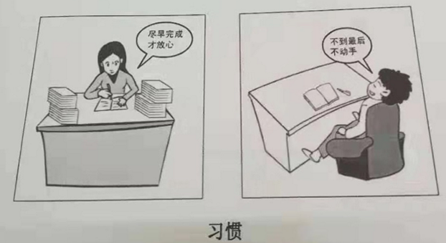
In the picture given above are two learners, who behave differently towards assignments. The one on the left carries out the task the minute she receives it, while her counterpart chose to procrastinate until the last minute. The difference between these two behaviors might lead to thoroughly opposite results, which could go stray from the original expectation.As far as I am concerned, when learning or doing a job, a good habit is far more useful than procrastination. The following points can account for my opinion.
In the first place, a good habit provides a safer environment for both your life and your career. Based on a most recent study, a growing body of evidence showed that most successful social elites, who never procrastinate, have admitted that the habit indeed is beneficial. Meanwhile, due to the busy schedule of university life, college students, who are engaged in studying, must find it helpful for them to improve efficiency when finishing the task early. A classic case in point is one of my classmates, who never postponed any plans. As a consequence, he gets A in all subjects all the time. Thus, from this standing point, there is nothing more beneficial and challenging than a good habit.
In view of the arguments above, we can safely draw a conclusion that with the ever-increasing material and cultural life, if we try our utmost to foster a good habit, our tomorrow will be both promising and rosy.

Part A
51. Directions:
Write a letter of about 100 words to the president of your university, suggesting how to improve students’ physical condition.
You should include the details you think necessary.
You should write neatly on the ANSWER SHEET.
Do not sign your own name at the end of the letter. Use “Li Ming” instead.
Do not write the address.(10 points)

Dear Sir or Madam,
I’m Liming, a student in the foreign language department. Recently, I noticed that most of our classmates couldn’t reach the standard during the physical condition test. Therefore, I’m writing this letter to suggest some measures, which might help to ease this situation.
First and foremost, a morning exercise routine is of great necessity. As far as I know, 90% of college students, if there is no morning class, don’t get up until 10 o’clock. This rule can be a compulsory task for us. Besides, there should be a body checkup at least once a year. This could be an informative event for students to have a better understanding of their body condition. If this could be done, the students, who suffered from deficiency, will have more stimulus to improve their physical condition. Moreover, the students should be encouraged to participate in the annual sports meeting, for which they will prepare and exercise a lot. As a consequence, their body condition could be strengthened.
Thank you for your time and consideration. Hopefully, my advice will be helpful for this situation.

Yours,
liming

Part B
52. Directions:
Write an essay of 160-200 words based on the following drawing. In your essay, you should
1）describe the drawing briefly,
2）interpret its intended meaning, and
3）give your comments.
You should write neatly on the ANSWER SHEET (20 points)
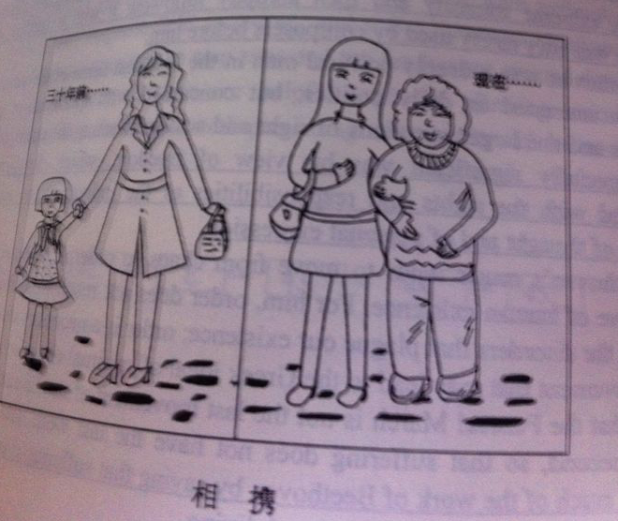

In the picture given above are two daughters and mothers,who were holding hands with each other. After 3 decades, their hands remain holding. The daughter has turned to the stronger and taller one while her mom has become weaker as time goes by. What the picture conveys goes far beyond merely how time flies. Instead, it reflected that we should return the favor to our parents when they get old.
In the first place, shouldering the responsibility of taking care of parents provides a safer environment for both parents’ and your life. Based on a most recent study, a growing body of evidence showed that most successful social elites, who have a flexible schedule, have admitted that they’re willing to look after their parents. Meanwhile, when living together with the parents, the communication between generations can be enhanced. a classic case in point is one of my classmates, who has a better relationship with her parents. He visits his parents twice a week. Thus, from this standing point, there is nothing more beneficial and challenging than taking care of parents.
In view of the arguments above, we can safely draw a conclusion that with the ever-increasing material and cultural life,If we try our utmost to undertake the responsibility of children, our tomorrow will be both promising and rosy.

Section IV Writing
Part A
51. Directions:
Write an e-mail of about 100 words to a foreign teacher in your college, inviting him/her to be a judge for the upcoming English speech contest.
You should include the details you think necessary.
You should write neatly on the ANSWER SHEET 2.
Do not sign your own name at the end of the e-mail. Use “Li Ming” instead.
Do not write the address. (10 points)

Dear James,
I’m Liming, a student in the foreign language department. Recently, we’re holding an English speech contest for the students in our department. Therefore, I’m writing this letter to invite you,with great respect, to be the judge of this event. You might need to pay attention to the following details.
First and foremost, there will be a meeting for all the judges on the day before the contest. You need to attend the meeting to discuss the criterion for scoring. Besides, you need to arrive in the classroom 5 fifteen minutes before the contest. Because, the host is going to introduce you to the audience when the event begins. After all the contestants finishing their speech, you need to give a remark about their performance. This could be a great help for them to improve on it.
Thank you for your time and consideration. Hopefully, we could have this honor to have you as our respectful judge.

Yours,
liming

Part B
52. Directions:
Write an essay of 160-200 words based on the following drawing. In your essay you should
1) describe the drawing briefly
2) explain its intended meaning, and
3) give your comments
You should write neatly on the ANSWER SHEET 2. (20 points)
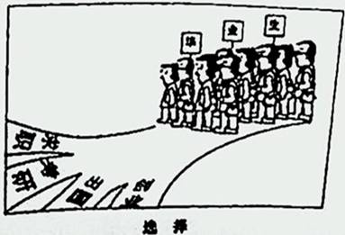
In the picture given above is/are a group of college students,who are facing choices upon graduation. There are four options for them: seeking a job, going to a postgraduate school, studying abroad or starting a business. What the picture conveys goes far beyond merely choices upon graduation. Instead, it reflected the dilemma of graduate students. It’s hard for them to make a choice with the ever-increasingly competitive society. As far as I am concerned, a master's degree is of great necessity. The following points can account for my opinion.
In the first place, owing to the prosperity of the economy in China, the whole country promotes the policy of higher education. Based on a most recent study, a growing body of evidence showed that most successful social elites, who rule the job market, have admitted that they prefer to hire students with a higher degree. Meanwhile, holding a master's diploma provides a safer environment for both your life and your career. A classic case in point is one of my classmates, who got a decent job with a master's degree. Thus, from this standing point, there is nothing more beneficial and challenging than going to postgraduate school.
In view of the arguments above, we can safely draw a conclusion that with the ever-increasing material and cultural life, if we try our utmost to be a lifelong learner, our tomorrow will be both promising and rosy.

Section IV Writing

Part A

- Directions:

One foreign friend of yours has recently graduated from college and intends to find a job in China. Please write an email to him/her to make some suggestions.
You should write about 100 words on the ANSWER SHEET.

Do not use your own name in the email. Use “ Li Ming” instead. (10 points)

Dear Jack,
How’s everything going? I’m your friend, who you may be very familiar with, Li Ming. I heard that you’ve graduated and are going to find a job in China. Therefore, I’m writing this email to offer you some suggestions about job hunting.
First, an elaborate C.V. would make you outstanding among hosts of applicants. Be sure to make it concise and attractive，because interviewers are tired of filtering out useful information. Meanwhile, you should do some rehearsals before the interview. You must face the interview with possible answers in mind. Preparations make you confident. Last but not least, dressing formally will show your respect and professionalism. A suit and a tie would work.
I hope my suggestions would be helpful. Good luck.
Yours sincerely,
Liming

Part B

- Directions:

Write an essay of 160-200 words based on the pictures below. In your essay, you should

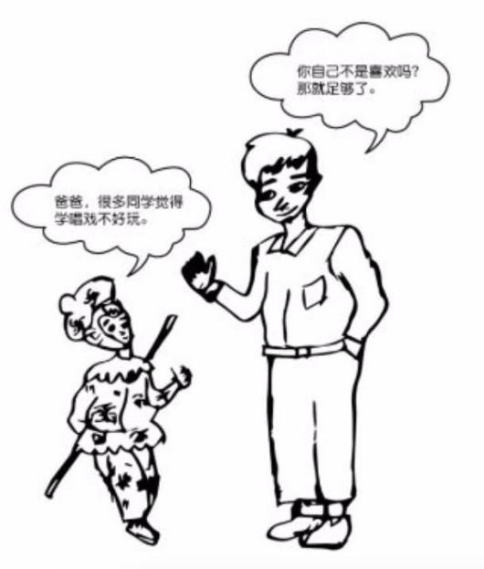
- describe the picture briefly,

- interpret its intended meaning, and

- give your comments.

You should write neatly on the ANSWER SHEET

In the pictures above are a father and a song, who behave differently towards others' opinions. The son on the left paid too much attention to others' opinions towards things he is passionate about, while his father thinks that it’s enough if interest can satisfy oneself. The difference between these two behaviors might lead to thoroughly opposite results, which could go stray from the original expectation. As far as I am concerned, when fostering a hobby, self contentment is far more useful than other people’s opinion. The following points can account for my opinion.
In the first place, emotional factors do play an important role in cultivating our hobbies. When you feel happy, the positive emotion ,which is helpful for your development, can be triggered. Based on a most recent study, a growing body of evidence showed that most successful social elites, who keep an unusual hobby, have admitted that they enjoy their hobbies. Meanwhile, due to the busy schedule of university life, college students who paid too much attention to people’s opinions, are especially susceptible to omnipresent stress. Via cultivating a self contending hobby, their long standing pressure can be effectively reduced. Thus, from this standing point, there is nothing more beneficial and challenging than developing a hobby which satisfies oneself.
In view of the arguments above, we can safely draw a conclusion that with the ever-increasing material and cultural life, if we try our utmost to keep the passion towards our hobby, our tomorrow will be both promising and rosy.

